

Article

Improving the Accuracy of Daylight Calculation with Impact of Sun-Shading Devices for the Russian Standard

Phuong Thi Khanh Nguyen^{1,a}, Ha Thi Hai Pham^{1,b,*}, Alecksei Kirillovich Solovyev^{2,c},
and Ashot Georgievich Tamrazyan^{2,d,}

1 National University of Civil Engineering, 55, Giai Phong, Hanoi, Vietnam
2 Moscow State University of Civil Engineering (MGSU), 26, Yaroslavskoye Shosse, Moscow, Russia
E-mail: ªphuongntk@nuce.edu.vn, ^{b,*}hapth@nuce.edu.vn (Corresponding author), ^{c}kafedraarxitektury@yandex.ru, ^{d}tamrazian@mail.ru

Abstract. Lighting engineering represents a complex scientific field, which requires the generalization of knowledge in assessing visual comfort, constructive and architectural solutions for the adaptation to the site climate. Global environmental issues and sustainable development require architectural design to serve the modern building achieve maximum energy performance. Especially in hot regions, the specific tasks of designing daylight systems cannot be sufficiently completed without carefully considering the problems of insolation and sunscreens. The present method in Russian regulations is a daylight factor method calculation with high accuracy under the overcast sky and without impact of shading devices. Unfortunately, this method revealed a few possible inaccuracies if considering the impact of shading devices and should be improved with the proposal of two coefficients $K_{shad}$ and $K_{ref}$, which replace the approximate factor $τ_{4}$. The results show that a significant effect from the shading coefficient reduces light entering the room. Light reflection from shading devices is slightly increased by up to 15% when the ground surface has a high reflectance. With this approach, it is possible to complete the method of side-lighting calculation with specific parameters and finishing surfaces of the shading devices. The research shows the potential of increasing light reflection to the room under the real sky with sunlight. Finishing the daylight factor calculation would potentially lead to the development of a method to define the window area in design stage to adequate the daylight requirements, which now processes most in the rule of thumb.

Keywords: Daylight Factor calculation, daylight assessment, lighting standard, sun-shading device, reflection coefficient.
ENGINEERING JOURNAL Volume 25 Issue 7
Received 10 June 2021
Accepted 8 July 2021
Published 31 July 2021
Online at https://engj.org/
DOI:10.4186/ej.2021.25.7.109
- Introduction

The design of envelopes and openings is important for improving daylight condition as a factor of indoor climate of buildings. Literature [1-6] indicated great contribution of well-daylit spaces to the occupants’ health and performance. To improve the accuracy of daylight analysis during the course of building envelope design, supportive calculation should be developed and provided to the designers.
In hot climates, external shades are useful elements for sun protection and therefore popularly introduced to the sun-exposed facades of buildings. Figure 1 shows successful designs of facades that are intended for Singapore and Malaysia as tropical countries. Studies by S Mirrahimi, Al-Tamimi, Kirimtat A., Abdullah, F. H., Cheong, K. H., Mettanant, V. et al. [7-12] provided insights into significant effects of shading on better indoor thermal and visual comfort. In these studies, empirical modeling and simulation were methods to analyze the relation between tropical sky radiation and energy consumption. In [13-15] (Y. W. Lim, H. Lee, Al-Masrani S.M. et al.), an indicator of “Daylight ratio” was introduced to evaluate how the reflection of a building enclosure affected daylight level in a room throughout different cases of orientation under intermediate sky conditions. As a part of Southeast Asia, Vietnam is grouped into the zone of tropical climate. Due to fast economic growth and rapid urbanization, high-rise apartments and office buildings are gaining increasing popularity in major cities. The main issue associated with these buildings lies on the building enclosure which is believed not to be well designed for hot and humid tropical climates that are characterized by high intensity of solar incidence. Shading and buffer spaces in forms of balconies, loggias, as well as elevated gardens were hardly considered in the conceptual design of a great deal of high-rise building projects. The regulation of microclimate therefore relies on M&E systems; however, it will lead to high energy consumption of the buildings. In Fig. 2, three multi- functional towers, Keangnam Landmark Tower (Hanoi), City administrative center (Danang) and Bitexco Financial Tower (Ho Chi Minh City) were demonstrated as representatives of fully glass-furnished envelopes. In these cases, it was necessary to use low-emissivity glass (Low e) to minimize thermal radiation in order to avoid heating inside the building and increase the construction cost significantly [16]. However, excessive annual expenditure on HVAC is foreseen when shading elements are absent on the glazed facades. Therefore, a better approach is using a more suitable window area, which are represented by Window to Wall Ratio (WWR) or Window to Floor Ratio (WFR). The influence of WWR value on energy savings potential of buildings was mentioned in [17-19]. Good selection of WWR values and typologies of shades are considered effective strategies to achieve expected performance and better visual comfort.

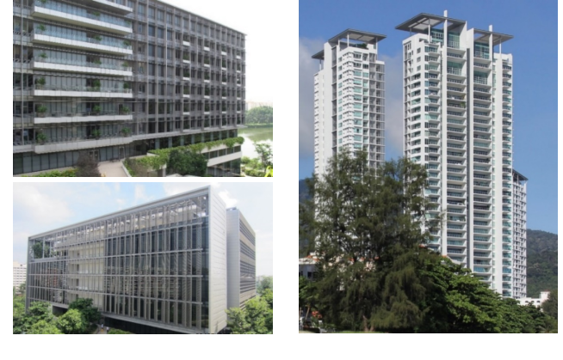

Fig. 1. Building envelopes with sun-shading devices, green-building solutions in tropical countries [source by authors].

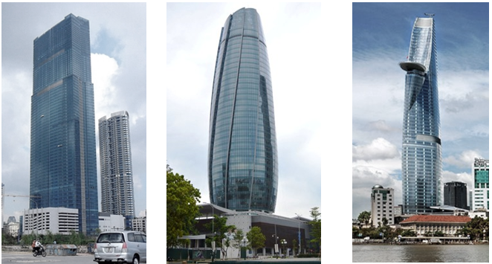
а). Keangnam Landmark Tower - Ha Noi [Photo credit: LG Viet Nam] | b). Building of administrative center of Danang city [Photo credit: Da Nang Department of Construction] | c). Bitexco Financial Tower – Ho Chi Minh city [Photo credit: Bitexco]
Fig. 2. Modern enclosing constructive solution in Vietnam.

DF methods – complex of design and assessment methods:

In the history of the daylight assessment, other daylight performance indicators based on the absolute value of illuminance such as sDA, UDI, ASE were developed to adequate the daylight requirements of an area under different sky models. These indicators are widely used in evaluating daylight using simulation software [20, 21]. However, when dealing with absolute value of illuminance, the design of the opening required by the early stages of the project using such indicators would not be optimal.
To determine the WWF or WFR requirements based on daylight needed in a space, the Daylight Factor is considerably the most reasonable method. In the document SP 23.102.2003 (Natural lighting of residential and public buildings, Russia) and SP 52.13330.2016 (daylighting and artificial lighting, Russia), the WFR was calculated using the minimum Daylight Factor - DF_{M} at the most unfavorable point of the room, i.e. at the point, in 1m from the furthest wall [22, 23].
The Daylight Factor concept was first introduced in 1895 by Trotter [24]. One of the earliest graphical methods developed, which received much recognition, was the Waldram diagrams for calculating the Sky Component (SC) [25]. In the 1930s, it was developed into Danhilux protractor, and has been commonly used in Russia due to its validated precision of geometric Daylight Factor for daylight assessment.

Russian standard for daylight calculation:

The typical sky in Russia is the overcast sky (for example: Moscow (56⁰N) and Saint Petersburg (57.7⁰N) [26, 27]. Daylight Factor is considered an indicator of convenience when designing openings due to its direct dependence on geometric Daylight Factor $ε$ (formula 1). From the cumulative of the diffuse horizontal illuminance, we can also define the requirement of time using daylight for working hours [28] For these reasons, the assessment with Daylight Factor (K.E.O) is widely used in Russian Standard and studies until now.
The Daylight Factor – K.E.O with side lighting in Russian standards SP 23-102-2003 and SP 52.13330.2016 [29, 30] can be obtained with the below expression:

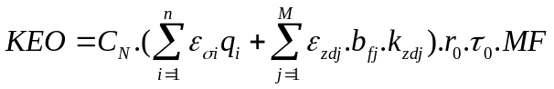 | (1)

where
$C_{N}$ is the coefficient of daylight climate corresponding to SP 52.13330.2016;
n is the number of sky sections visible through the light opening from the fixed point;
$ε_{σi}$ is the geometric Daylight Factor at the fixed point with side opening, taking into account direct light from the i-th section of the sky;
$q_{i}$is the coefficient of non-uniformity of the i-th section brightness of the cloudy sky CIE;
М is the number of sections of the facades of the opposing buildings visible through the opening from the fixed point;
$ε_{zdj}$ is the geometric Daylight Factor at the fix point with side opening, taking into account the light reflected from the j-th section of the facades of the opposing buildings;
${\text{b}}_{\text{fj}}$ is the average relative brightness of the j-th section of the facades of the opposing buildings, the physical essence of this coefficient is similar to the coefficient q:

$$b_{f}=\frac{L_{\text{zd}}}{L_{z}}.\frac{E_{\text{uniform sky}}}{E_{\text{overcast sky}}}$$ | (2)

From formula (2), $L_{zd}$ is the brightness of the opposing building, $L_{z}$ is the brightness of the sky at zenith, E_{uniform sky} is the horizontal illumination in the open air under uniformity sky, Е_{overcast sky} is the illumination on the horizontal surface with brightness distribution of overcast sky, standardized by CIE.
k_{zdj} is the coefficient taking into account changes in the internal reflected component of the Daylight Factor in the room in the presence of opposing buildings, determined by the formula:

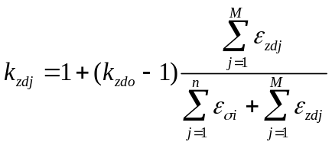 | (3)

where: k_{zdo} coefficient that takes into account changes in the internal reflected component of the Daylight Factor in the room when the sky is completely or partially closed by buildings visible from the fixed point;
r_{o} is the coefficient takes into account the increase of Daylight Factor with side lighting due to light reflected from the surfaces of the room and the external obstructions;
τ_{o} is the total light transmittance, determined by the formula:

$τ_{o}=τ_{1}.τ_{2}.τ_{3}.τ_{4}$ | (4)

where: τ₁ is the coefficient of light transmission of the material, τ₂ is the coefficient taking into account the light loss in the bindings of the opening, τ₃ is the coefficient taking into account the light loss in the bearing structures (with side lighting τ₃ = 1), τ₄ is the coefficient taking into account the light loss in the sun-shading devices.
MF is the operating factor determined according to [29, 30];

Target of the study:

In the last version of daylight standards, the daylight assessment was developed to be adequate with different sky conditions. The coefficient of daylight climate C_{N} and the coefficient of non – uniformity of the sky q_{i} was up to date from the fifteen sky models of Kittler [31]. The three main components of DF were described:
- Luminance of Sky Component and Obstruction Component

(SC&OC) = 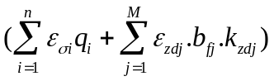

- Interior Reflection Component (IRC) = r_{o}
- Exterior Reflection Component (ERC) = τ₄ (nested in τ_{o})
Notably, τ₄ represents influence of the shading devices and other different exterior components, which may vary from 0.75 to 0.90. In this case, the effects of external shading devices (form, sizing and materials) are not taken into account. That also means this estimation method of daylight amount with shading devices are unsuitable.
This study proposed further development of this method for the analysis of daylight when external shades are introduced. The suggested research target is: calibrating coefficient τ₄ with proposing the coefficients, considering the impact of horizontal shading device and ground reflectance on the original Daylight calculation.

- Methodology

Under the overcast sky, diffuse radiation, as well as diffuse illumination, is characterized by the property of steadiness and is not influenced by the light opening orientation. At the same time, direct radiation is characterized by a dynamic property, changes rapidly in time and depends on the orientation. In Real states of the sky, i.e. in the intermediate sky, the level of diffuse illumination depends on different cloud conditions and accordingly, the vertical diffuse illumination depends on the position of the Sun.
In the field of design, direct light that inevitably causes discomfort glare and increases cooling load should be avoided. Diffuse source, in contrast, provides buildings with more stable light amount and better visual comfort. External fins, on one hand, prevent the penetration of direct sunlight, but on the other hand, increase the amount of reflected light into interior space. The typologies and dimension of shades should be determined in relation to building location, orientation and occupants’ expectation.
With the presence of shading devices, a part of the sky light will be deducted by shading devices while the other part would be reflected from exterior surfaces (shading device surface and ground) onto the glass windows and into the building. The increased or decreased amount of light reflected onto glass window surfaces will take into account the reflection coefficient K_{ref} (>1) and shading coefficient K_{shad} (<1). These coefficients will then be multiplied into the original Daylight Factor calculation in the formula (1). Physical light transmission analysis and mathematical analysis are used to determine the two proposed coefficients above.

  - Coefficient of Reduction of Diffuse Illuminance in the Room with Sun-Shading Device – K_{shad}

The hypothesis must be accepted: The reflection of natural light from adjacent surfaces is considered total diffuse reflection. The intensity of diffuse illumination from the sky is a linear function with the intensity of diffuse radiation from the sky, formula (5) represents this ratio [32, 33].

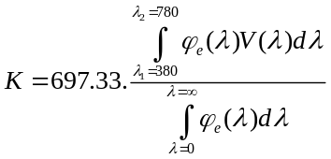 | (5)

where
K is the light emission equivalent or luminous efficiency, Klx/W.m² or Lm/W;
697.33 is maximum spectral sensitivity of vision which befalls at 555 nm;
ϕ_{e} (λ) is the flux density at wavelength λ ( nm);
V(λ) is the value of the photopic spectral luminous efficiency for that wavelength.
Consistent with the linear relationship between diffuse illumination and diffuse radiation, in the presence of shading devices, the coefficient considering the decrease in diffuse illumination in the room is equal to the coefficient considering the decrease in diffuse radiation - K_{shad}:

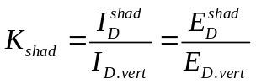 | (6)

where
I_{D}^{shad} is the intensity of diffuse solar incidence on window with protection, W/m²;
I_{D.vert.} is the intensity of diffuse solar incidence on window without protection, W/m²;
E_{D}^{shad} is the diffuse Illuminance on window with protection, lux;
E_{D.vert.} is the diffuse Illuminance on glassed window without protection, lux.
Since the rays of diffuse radiation go from the sky to the calculated point, it is needed to set up the origin of coordinates on the window surface. Taking the middle of the upper edge of the window as the origin (O') leads to an increase in the solid angle of the sky dome Z-Z₃, while the origin (O'') as the middle of the lower edge leads to a decrease in the solid angle of the sky dome; hence the center point (O) of the window is fixed as the calculation point (Fig. 3). According to [32, 33], assuming that the diffuse radiation is uniformly distributed, K_{shad} could be calculated as:

$$K_{\text{shad}}\text{ =1}\text{2}{\text{Ψ}}_{\text{o.czu}}$$ | (7)

where
l - emissivity from the sky at the center point of the window;
ψ_{о.czu.} - emissivity from ½ shading element at the center point of the window.

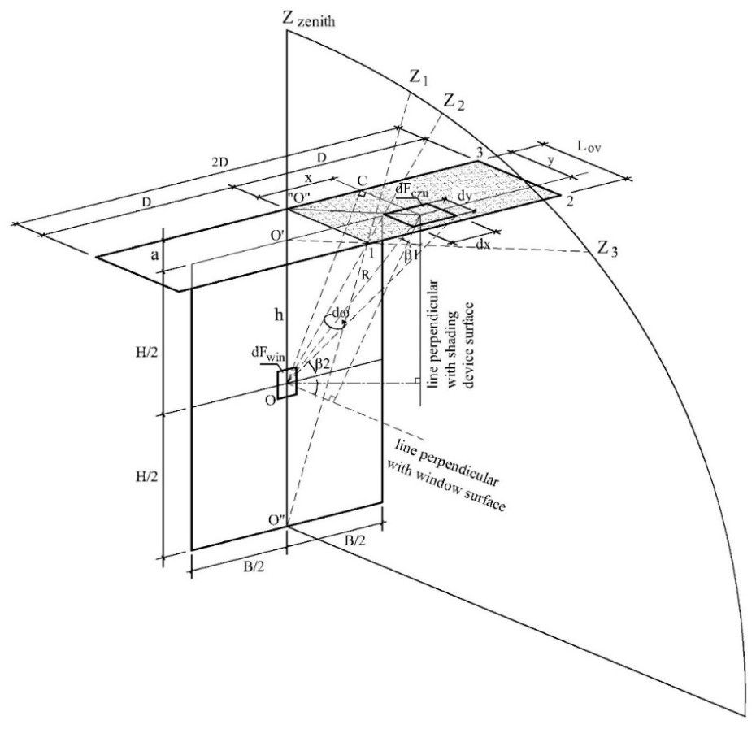
Fig. 3. Illustration of the calculation of the emissivity between the surface of the sun-shading element and the center point O of the window for the proposal of K_{shad.}

  - The Coefficient of Increase of the Illuminance due to Reflected Light from Different Surfaces Of Sun Shading Devices – K_{ref.}

The reflection of diffuse light from horizontal shading devices is taken into account by the coefficient K_{ref} and is determined according to Lambert's law [34-36]. The basic formula is described:

$$\text{dE=}\frac{\text{L.dx.dy.cos}\text{α}\text{.cos}\text{β}}{r^{2}}$$ | (8)

where L is area brightness dS.
Reflected illumination from a horizontal shading device – K_{ref} is characterized by the process of light reflection from the ground or from another adjacent reflective surface onto the lower surface of the horizontal shading element and from the shading device surface to point O, which is in the center of the window. This process is characterized by reflections between perpendicular and parallel planes. The reflected illumination at the O point is expressed in two stages:

- The first stage is reflection from the first reflective surface on the horizontal shading device, characterized by reflection between two parallel planes.
The reflected surface must be divided into elementary sections ΔS = Δx. Δy and sum the amount of reflected light from each of the sections of the reflected surface to each of their calculated points in the center of similar elementary sections (Fig. 4(a)):

$$E_{2}=\int_{0}^{l}{dx}\int_{0}^{∞}{\frac{2.E_{1}.ρ_{1}.h_{1}^{2}}{π[h_{1}^{2}+(x-b)^{2}+y^{2}]^{2}}}dy$$ | (9)

- The second stage is reflection from the horizontal shading device onto the window, characterized by reflection between two perpendicular planes.
For a 2D-long and L_{ov} - wide horizontal single blade, expression for reflected illuminance is:

$$E_{\text{ref.hor.shad.}}=\int_{0}^{\text{Lov}}{\text{dx}}\int_{0}^{D}{\frac{\text{2.}{\text{E}}_{2}\text{.}{\text{ρ}}_{2}\text{.}{\text{h}}_{2}\text{.x}}{π[h_{2}^{2}\text{+}{\text{x}}^{2}\text{+}{\text{y}}^{2}]^{2}}}\text{dy}$$ | (10)

where
E₁ is the diffuse illuminance from primary reflectance, Lux;
Е₂ is the diffuse illuminance from bottom surface of the blade, Lux;
ρ₁ is the primary reflectance (from the ground or the blade);
ρ₂ is the secondary reflectance (from the blade);
l is the range of primary reflecting plane, m;
h₂ is the distance between the reflected point E₂ and the calculated point O along the perpendicular line, m.
h₁ is the distance between the reflected point E₁ and the calculated point E₂ along the perpendicular line, m.

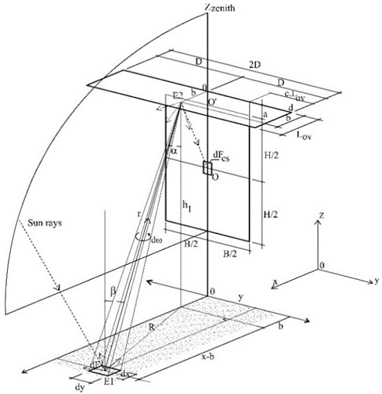
(a)

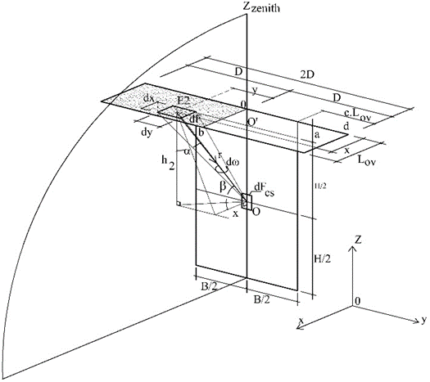
(b)

Fig. 4. (a), (b). Illustration of the calculation of the emissivity between the surface of the sun-shading element and point O at the center of the window for the proposal of K_{ref.}

- Results and Discussion

To obtain the emissivity ψ_{о.shad}, the ratio of the differential of the window area at the center point (dF_{o}) and the differential of the shading device’s area (dF_{czu}) was proposed as shown in Fig. 3, like the ratio of the projection area of the solid angle “ω”, projected onto the surface of the window glazing to the value “ π”:

$$Ψ_{\text{dFo-dFczu}}=\frac{\text{d}{\text{F}}_{\text{czu}}\text{.cos}{\text{β}}_{1}\text{.cos}{\text{β}}_{2}}{\text{π}{\text{R}}^{2}}$$ | (11)

Obtained from two equilateral triangles (dF_{о}.0.dF_{czu} ) and (dF_{о}.C.dF_{czu}): $cosβ_{1}=\frac{y}{R}$; $cosβ_{2}=\frac{h}{R}$; $R^{2}=y^{2}+x^{2}+h^{2}$; It can be drawn that:

$$Ψ_{\text{dFo-dFczu}}=\frac{\text{hy.dy.dx}}{π(y^{2}\text{+}{\text{x}}^{2}\text{+}{\text{h}}^{2})^{2}}$$ | (12)

Formula (12) can be derived as:

$$ψ_{dFo-dFczu}=\frac{1}{2π}arctg\frac{D}{h}-\frac{h}{2π\sqrt{L_{ov}^{2}+h^{2}}}arctg\frac{D}{\sqrt{L_{ov}^{2}+h^{2}}}$$ | (13)

where
D is ½ lengths of shading device, m;
L_{ov} is the width of the shading device, m;
a is the distance from the top of the window to the surface of the sun-shading device, m;
h is the distance from calculated point O to the surface of shading device: h=H/2+a with horizontal shading device; h=B/2+b with vertical shading device.
The coefficient, presented for infinite horizontal and vertical, as well as for combined shading devices were proposed in [32, 33] and included in the manual 2.91 to SniP 2.04.05-91 (1993) [37]. From the general formula (13), for a finite horizontal shading device with a length 2D, the coefficient of diffuse radiation reduction - K_{shad} into the space in the presence of final horizontal shading device is developed on the studies [38-40]. Since the beams of the diffuse radiation are centripetal, it is essential to specify the origin on the window surface to calculate K_{shad} (Fig. 5) and developed:

$$K_{shad}=1-2ψ_{o.czu}$$  $$=1-\frac{2}{π}\left(arctg\frac{D}{h}-\frac{h}{\sqrt{L_{ov}^{2}+h^{2}}}.arctg\frac{D}{\sqrt{L_{ov}^{2}+h^{2}}}\right)$$ | (14)

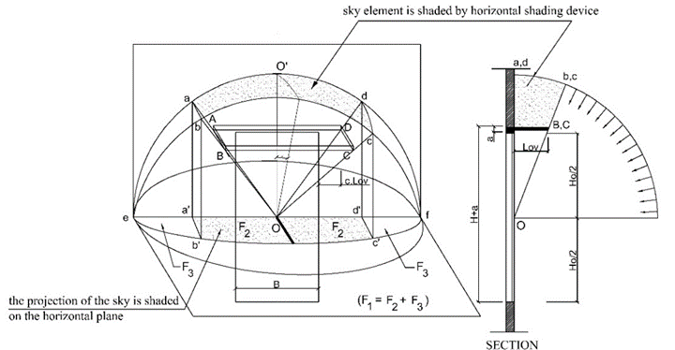
Fig. 5. The part of the sky shaded by the horizontal shading device.

The reflectance coefficient caused by a finite horizontal blade can be estimated with:

$$K_{\text{ref.}}=\frac{E_{\text{D.shad.}}\text{+}{\text{E}}_{\text{ref.shad.}}\text{+}{\text{E}}_{\text{ref.ground.}}}{E_{\text{D.shad.}}}$$ | (15)

where
Diffuse illuminance at the surface of window with the shading device is calculated:

$$E_{\text{D.shad.}}=\frac{1}{2}E_{D}\text{.}{\text{K}}_{\text{shad}}$$ | (16)

Reflectance illuminance from shading device is defined:

$$E_{\text{ref.}}=\frac{E_{2}.ρ_{2}}{π}\left[F(D)-F(0)\right]$$ | (17)

with:

$$F(y)\text{=arctg}\left(\frac{y}{h_{2}}\right)-\frac{h_{2}}{\sqrt{h_{2}^{2}\text{+}L_{ov}^{2}}}\text{arctg}\left(\frac{y}{\sqrt{h_{2}^{2}\text{+}L_{ov}^{2}}}\right)$$ | (18)

Components reflected from the ground part with a length of 2d and a width of l:

$$E_{\text{ref.ground.}}=\frac{E_{1}\text{.}{\text{ρ}}_{1}}{π}\left[F(d)-\text{F}(0)\right]$$ | (19)
With

$$F\left(y\right)=arctg\left(\frac{y}{h_{3}}\right)-\frac{h_{3}}{\sqrt{h_{3}^{2}+l^{2}}}.arctg\left(\frac{y}{\sqrt{h_{3}^{2}+l^{2}}}\right)$$
(20)
Finally, the light reflected with a finite shading device with a length of 2D, width L (Fig. 4) could be obtained with K_{ref} :

$$K_{ref}=1$$ | (21)
$$+\frac{\frac{ρ_{1}.ρ_{2}}{π^{2}}\left[F\left(D\right)–F\left(0\right)\right].\left[F\left(l–b\right)–F\left(–b\right)\right]+\frac{ρ_{1}}{π}\left[F\left(d\right)–F\left(0\right)\right]}{\frac{1}{2}.K_{shad}}$$

where [F(D)-F(0)] according to the formula:
$$F(y)\text{=arctg}\left(\frac{y}{h_{2}}\right)–\frac{h_{2}}{\sqrt{h_{2}^{2}\text{+}L_{ov}^{2}}}arctg\left(\frac{y}{\sqrt{h_{2}^{2}\text{+}L_{ov}^{2}}}\right)$$ | (22)

[F(l-b)-F(-b)] according to the formula:

$$F\left(x\right)=\frac{d}{\sqrt{h_{1}^{2}+d^{2}}}arctg\left(\frac{x}{\sqrt{h_{1}^{2}+d^{2}}}\right)+$$  $$+\frac{x}{\sqrt{h_{1}^{2}+x^{2}}}arctg\left(\frac{d}{\sqrt{h_{1}^{2}+x^{2}}}\right)$$ | (23)

F(d)-F(0)] according to the formula:

$$F\left(y\right)=arctg\left(\frac{y}{h_{3}}\right)–\frac{h_{3}}{\sqrt{h_{3}^{2}\text{+}l^{2}}}.arctg\left(\frac{y}{\sqrt{h_{3}^{2}+l^{2}}}\right)$$ | (24)

The improved formula (1) has the form:
$$\text{КЕО} \text{= }{\text{K}}_{\text{shad}}\text{.}{\text{K}}_{\text{ref}}.(\sum_{\text{i=1}}^{L}{ε_{\text{σ}\text{i}}q_{i}+\sum_{\text{j=1}}^{M}{ε_{\text{zdj}}\text{.}{\text{b}}_{\text{fj}}\text{.}{\text{k}}_{\text{zdj}})}}\text{.}{\text{r}}_{o}\text{.}{\text{τ}}_{o}\text{.MF}$$ | (25)

where
$τ_{o}\text{= }{\text{τ}}_{1}\text{.}{\text{τ}}_{2}\text{.}{\text{τ}}_{3}$; The coefficient τ₄ in formula (4) is replaced by K_{shad} and K_{ref}.
h = H/2+a;
h₁ is the distance between the reflected point E₁ and the calculated point E₂ along the perpendicular line, m;
h₂ is the distance between the reflected point E₂ and the calculated point O along the perpendicular line, m.
h₃ is the distance between the reflected point E₁ and the calculated point O along the perpendicular line, m;
d is 1/2 first reflective surface length, m
l is the width of the first reflective surface, m
b is the distance from the calculated point E₂ (in the center of the shading element surface) to the inner border of the shading device, m.
To evaluate the effectiveness of the two coefficients K_{shad} and K_{ref} in daylighting calculation, use formula (14) and (21) to calculate these coefficients in the case of a window with the height H=1.8 m; shaded by a horizontal sun-shading device with length 2D=1 m and horizontal depth varies from 0.1 ÷ 1 m. Three cases of coefficients ρ₁ and ρ₂ were examined:
- Case 1: coefficient of reflectance ρ₁ = ρ₂ = 0.5
- Case 2: coefficient of reflectance ρ₁ = 0.8, ρ₂ = 0.5
- Case 3: coefficient of reflectance ρ₁ =0.5, ρ₂ = 0.8
The results of calculation represented below:

with a high reflectivity of the ground surface  with a medium reflectivity of the ground surface  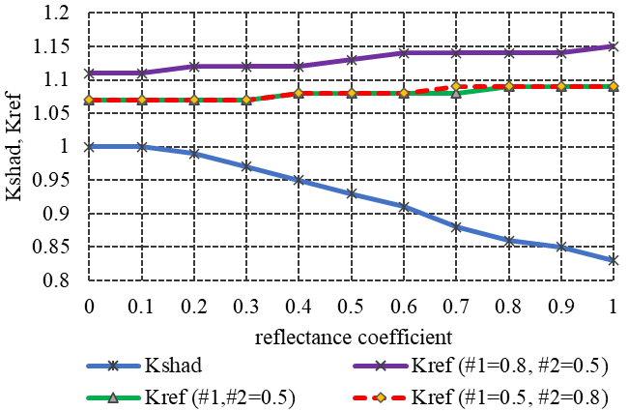 | 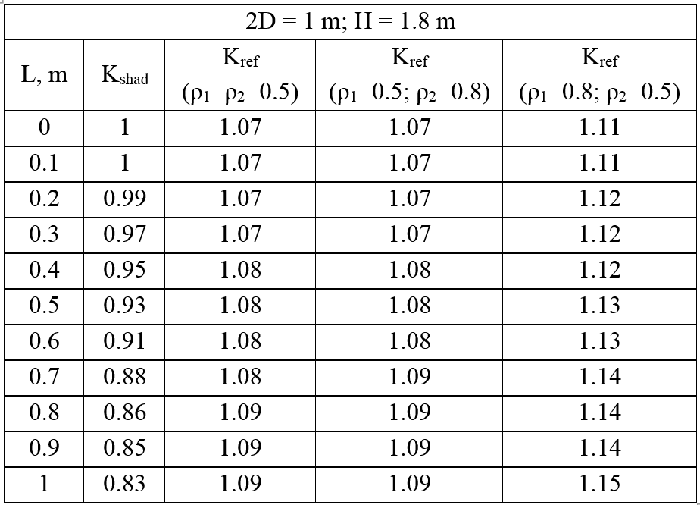
Fig. 6. The results of impact of the K_{shad} and K_{ref} depend on the horizontal shading device’s width and the reflectance coefficient ρ₁, ρ₂.

Discussion
The correction of ERC components by two proposed coefficients K_{shad} and K_{ref} helps completing the method of evaluating daylight with Daylight Factor when considering shading devices or affecting adjacent surfaces. The research results have been analyzed through the effect of each coefficient on the daylight assessment. Based on the Fig. 6, these comments can be given:
- When horizontal depth of the shading device increases from 0.1 to 1 m, K_{shad} decreases from 1 to 0.83,
While K_{ref} increases slightly. In the case the coefficient ρ₁ has low value, K_{ref} increases very slightly; when ρ₁ reaches 0.8, K_{ref} begins to be significantly affected up to 15%.
- Under the CIE overcast sky, this formula shows that the coefficient of shading K_{shad} has the main influence, although at a high brightness of the intermediate sky, reflecting the value of K_{ref} would also be significant. It is expected that under the intermediate sky with sun, the shading devices can significantly increase the reflected illumination into spaces, which are located on the ground floor.
The proposed daylight calculation with impact of sun-shading devices for the Russian standard developed based on the original formula can have certain advantages:
- Evaluating daylight by relative value (in this case, Daylight Factor) helps solving problems upon the requirement of windows design and the calculation of daylight performance.
- The original formula allows us to consider the impact of Obstruction Components (the opposing buildings). The determination geometric Daylight Factor by graphics Danhilux, in which the sky was divided into 10.000 patches confirmed exact results of calculation. The development of the original formula with the proposed coefficients taking into account the impact of the shading devices allows programming to calculate the Daylight Factor with different sizes and any reflectance values of the shading surfaces.
The proposed methodology was approved and compared with the Design Builder computer program (Radiance engine); Russian Standards; and measurements on the physical model. The results show the best agreement of the proposed method with the experiment (Fig. 7). The measurement and theory calculation accept under the Overcast Sky condition in Russia.
According to the proposed method, the Daylight Factor performance in space can be calculated under the condition of cloudy, as well as under the condition of an intermediate sky, taking into account the reflection of skylight with real diffuse horizontal illuminance from adjacent surfaces to the room. The second condition will be obtained in the futher works.

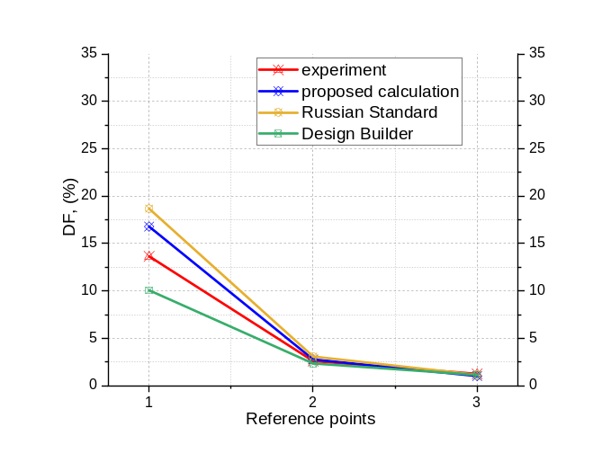 | 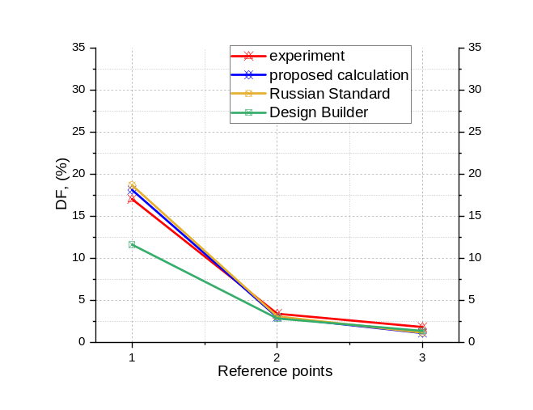
a) coefficient of reflectance F:W:C  0.22:0.40:0.88 | b) coefficient of reflectance F:W:C  0.40:0.40:0.40
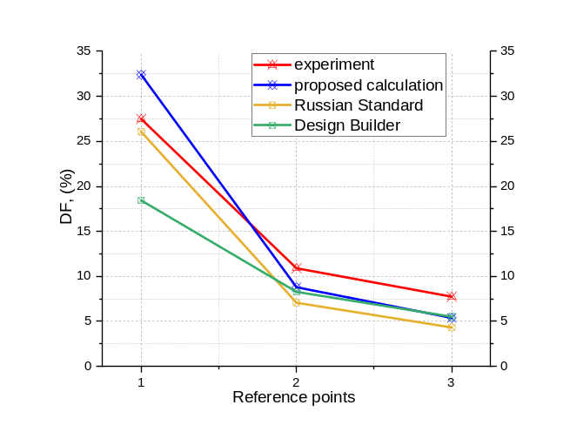 | 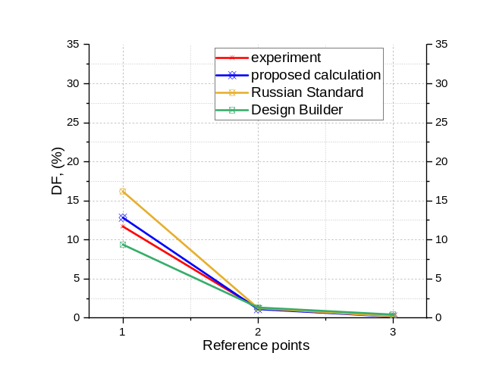
c) coefficient of reflectance F:W:C  0.88:0.88:0.88 | d) coefficient of reflectance F:W:C  0.22:0.22:0.22
 | Experiment |  |  | Proposed method |  |  | Russian Standards |  |  | Design Builder
ref.points | 1 | 2 | 3 | 1 | 2 | 3 | 1 | 2 | 3 | 1 | 2 | 3
Coefficient of reflectance Floor:Walls:Ceiling 0.22:0.40:0.88
DF, % | 13.65 | 2.59 | 1.24 | 16.79 | 2.76 | 1.01 | 18.68 | 3.07 | 1.13 | 10.06 | 2.34 | 1.13
Coefficient of reflectance Floor:Walls:Ceiling 0.40:0.40:0.40
DF, % | 17.02 | 3.39 | 1.80 | 18.11 | 2.98 | 1.09 | 18.68 | 3.07 | 1.13 | 11.61 | 2.82 | 1.35
Coefficient of reflectance Floor:Walls:Ceiling 0.88:0.88:0.88
DF, % | 27.48 | 10.90 | 7.74 | 32.41 | 8.79 | 5.39 | 26.07 | 7.07 | 4.33 | 18.44 | 8.28 | 5.52
Coefficient of reflectance Floor:Walls:Ceiling 0.22:0.22:0.22
DF, % | 11.72 | 1.26 | 0.30 | 12.85 | 1.14 | 0.19 | 16.19 | 1.26 | 0.22 | 9.40 | 1.35 | 0.44
Fig. 7. Results of the DF study with a cloudy sky, in Moscow, on June 26th at 14:00.

- Conclusions and Future Work

In the paper, the limitations of the estimation method introduced in the Russian standards when assessing daylight performance of the side-lighting affected by shading devices were discussed. The use of coefficient τ₄ and considering the significantly reducing amount of light due to sun-shading devices result in imprecise evaluation of daylight efficiency.
The study proposes a method for evaluating daylight with the correction of the coefficient τ₄ in the Russia standard with coefficients that consider shading and light reflection from the horizontal shading devices. It is propounded to solve the calculation of determining the shading and reflection coefficients of direct diffuse illumination from the sky and light reflection from the horizontal shading devices using the coefficients K_{shad} and K_{ref} with specific parameters and finishes. The influences of the protrusion dimension and finished surface of the shading devices with a medium and high reflectivity were analyzed. The results show that under the overcast, the value K_{shad} has more effect on the calculation while the K_{ref} is only obviously affected when using the first reflective surface with high reflectivity.
Improving the accuracy of the daylight calculation with impact of sun-shading devices allows us to assess daylight in the buildings in hot and tropical regions, where the architecture and the enclosure structures are characterized by openings with sun-shading devices as the most effective elements for blocking direct sunlight, resistance heat radiation in the room and increase visual comfort. Further research should be devoted to determining the values of K_{shad} and K_{ref} for various types of shading devices and consider the impact of the Sunlight.

References

- J. Mardaljevic, L. Heschong, and E. Lee, “Daylight metrics and energy savings,” Lighting Research & Technology, vol. 41, no. 3, pp. 261-283, 2009.
- P. Tregenza and M. Wilson, Daylighting: Architecture and Lighting Design. Routledge, Jan. 11, 2013, pp. 59-77.
- F. Amirifard, S. A. Sharif, and F. Nasiri, “Application of passive measures for energy conservation in buildings—A review,” Advances in Building Energy Research, vol. 13, no. 2, pp. 282-315, 2019. [Online]. Available: https://doi.org/10.1080/17512549.2018.1488617
- S. Lou, D. H. Li, J. C. Lam, and E. W. Lee, “Estimation of obstructed vertical solar irradiation under the 15 CIE Standard Skies,” Building and Environment, vol.103, pp.123-133, 2016.
https://doi.org/10.1016/j.buildenv.2016.04.005
- P. R. Boyce, Human Factors in Lighting. CRC Press, 2014.
- P. Tregenza and J. Mardaljevic, “Daylighting buildings: Standards and the needs of the designer,” Lighting Research & Technology, vol. 50, no. 1, pp. 63-79, 2018. [Online]. Available: https://doi.org/10.1177/1477153517740611
- S. Mirrahimi, M. F. Mohamed, L. C. Haw, N. L. Ibrahim, W. F. Yusoff, and A. Aflaki, “The effect of building envelope on the thermal comfort and energy saving for high-rise buildings in hot–humid climate,” Renewable and Sustainable Energy Reviews, vol. 53, pp. 1508-1519, 2016. [Online]. Available: https://doi.org/10.1016/j.rser.2015.09.055
- N. A. Al-Tamimi and S. F. Fadzil, “The potential of shading devices for temperature reduction in high-rise residential buildings in the tropics,” Procedia Engineering, vol. 21, pp. 273-282, 2011. [Online]. Available: https://doi.org/10.1016/j.proeng.2011.11.2015
- A. Kirimtat, B. K. Koyunbaba, I. Chatzikonstantinou, and S. Sariyildiz, “Review of simulation modeling for shading devices in buildings,” Renewable and Sustainable Energy Reviews, vol. 53, pp. 23-49, 2016. [Online]. Available:
https://doi.org/10.1016/j.rser.2015.08.020
- F. H. Abdullah, N. H. Majid, and R. Othman, “Defining issue of thermal comfort control through urban mosque façade design,” Procedia-Social and Behavioral Sciences, vol. 234, pp. 416-423, 2016. [Online]. Available: https://doi.org/10.1016/j.sbspro.2016.10.259
- K. H. Cheong, Y. H. Teo, J. M. Koh, U. R. Acharya, and S. C. Yu, “A simulation-aided approach in improving thermal-visual comfort and power efficiency in buildings,” Journal of Building Engineering, p. 100936, 2019. [Online]. Available:
https://doi.org/10.1016/j.jobe.2019.100936
- V. Mettanant and P. Chaiwiwatworakul, “Automated vertical blinds for daylighting in tropical region,” Energy Procedia, vol. 52, pp. 278-286, 2014. [Online]. Available:
https://doi.org/10.1016/j.egypro.2014.07.079
- Y. W. Lim and C. Y. Heng, “Dynamic internal light shelf for tropical daylighting in high-rise office buildings,” Building and Environment, vol. 106, pp. 155-166, 2016. [Online]. Available:
https://doi.org/10.1016/j.buildenv.2016.06.030
- H. Lee, K. Kim, J. Seo, and Y. Kim, “Effectiveness of a perforated light shelf for energy saving,” Energy and Buildings, vol. 144, pp. 144-151, 2017. [Online]. Available:
https://doi.org/10.1016/j.enbuild.2017.03.008
- S. M. Al-Masrani, K. M. Al-Obaidi, N. A. Zalin, M. A. Isma, “Design optimisation of solar shading systems for tropical office buildings: Challenges and future trends,” Solar Energy, vol. 170, pp. 849-872, 2018. [Online]. Available:
https://doi.org/10.1016/j.solener.2018.04.047
- QCVN 09.2017 Technical Regulation/BXD Buildings of Efficient Energy Usage (in Vietnamese). Hanoi: Construction Publisher, 2017.
- В. Г. Гагарин, Е. В. Коркина, И.А. Шмаров. Теплопоступления и теплопотери через стеклопакеты с повышенными теплозащитными свойствами. Academia. Архитектура и строительство. (Gagarin VG, Korkina EV, Shmarov IA. Heat gain and heat loss through double-glazed windows with increased heat-shielding properties. Academia. Architecture and construction). 2. pp. 106-110, 2017.
- V. G. Gagarin, “Requirements for thermal protection and energy efficiency in the project of the updated Building codes “Thermal protection of buildings”,” in Housing Construction, V. G. Gagarin and V. V. Kozlov, Eds. 2011, vol. 8., pp. 2-6.
- T. K. P. Nguyen, A. G. Tamrazyan, N. T. Kien, and P. Van Luong, “Window to floor ratio in the design stage in considering to visual-thermal comfort and safety in building,” IOP Conference Series: Materials Science and Engineering, vol. 675, no. 1, p. 012010, 2019, doi:10.1088/1757-899X/675/1/012010.
- E. Brembilla and J. Mardaljevic, “Climate-Based Daylight Modelling for compliance verification: Benchmarking multiple state-of-the-art methods,” Building and Environment, vol. 158, pp. 151-164, 2019.
- Z. S. Zomorodian and M. Tahsildoost, “Assessing the effectiveness of dynamic metrics in predicting daylight availability and visual comfort in classrooms,” Renewable Energy, vol. 134, pp. 669-680, 2019.
- SP 23-102-2003, Естественное освещение жилых и общественных зданий. Госстроя России, (Natural Lighting of Residential and Public Buildings, Gosstroya Rossii), Moscow, 2005. [Online]. Available:
http://docs.cntd.ru/document/1200035250
- SP 52.13330.2016, Естественное и исскуственное освещение. Минстрой России. (Daylighting and artificial lighting. Minstroy Rossii), Moscow, 2017. [Online]. Available:
http://docs.cntd.ru/document/456054197
- J. W. T. Walsh, “The early years of Illuminating engineering in Great Britain,” Transactions of the Illuminating Engineering Society, vol. 15, no. 3, pp. 49-60, 1951.
- R. G. Hopkinson, P. Petherbridge, and J. Longmore, Daylighting. London: Heinemann, 1966.
- A. K. Solovyov and T. H. P. Nguyen, “The calculation method for light climate parameters based on sun-lighting efficiency and the comparative analysis of light climate in Hanoi and Moscow,” Light & Engineering, vol. 27, no. 5, pp. 67-71, 2019.
- V. А. Zemtsov, А. K. Solovyev, and И. А. Shmarov, Yarkostnyye parametry standartnogo neba MKO v raschotakh yestestvennogo osveshcheniya pomeshcheniy i ikh primeneniye v razlichnykh svetoklimaticheskikh usloviyakh Rossii. (Brightness parameters of the CIE standard sky in calculations of daylighting of premises and their application in various climatic conditions in Russia), Svetotekhnika, vol. 6, pp. 55-61, 2016.
- P. T. K. Nguyen, A. K. Solovyov, and H. T. Nguyen, “The simple way to upgrade the daylight standard for tropical Vietnam,” Light & Engineering, vol. 28, no. 3, pp. 60-69, 2020.
- H. S. Hens, Building Physics-Heat, Air and Moisture: Fundamentals and Engineering Methods with Examples and Exercises. John Wiley & Sons, 2017.
- P. N. Dang and P. T. Ha, Heat and Architectural Climatics. Hanoi: Construction Publisher, 2002.
- S. Darula and R. Kittler, “CIE general sky standard defining luminance distributions,” in Proceedings eSim, 2002, pp. 11-13.
- P. N. Dang, “The thermal regime of the building in the climatic conditions of Vietnam,” (in Russian) Thesis of Doctor of Technical Sciences, Moscow, 1978.
- P. N. Dang and V. N. Bogoslovskiy, “Theological. Calculation of the total heat transferred into the room through the window,” (in Russian) Water Supply and San. Technics., vol. 1, pp. 10-15, 1973.
- V. A. Zemtsov, A. K. Solovyov, and I. A. Shmarov, “Luminance parameters of the standard CIE sky within natural room illumination calculations and their application under various light climate conditions,” (in Russia) Light & Engineering, vol. 25, no. 1, pp. 106-114, 2017.
- N. T. Phuong, “Luminance distributions in the tropical sky conditions,” Magazine of Civil Engineering, vol. 84, no. 8, pp. 192-204, 2018, doi: 10.18720/MCE.84.18
- N. T. Phuong, A. Solovyov, and N. T. Hoa, “Correction of the uneven brightness coefficient for the tropical sky conditions,” (in Vietnamese) Journal of Science and Technology in Civil Engineering, vol. 13, no. 3V, pp. 136-147, 2019. [Online]. Available:
https://doi.org/10.31814/stce.nuce2019-13(3V)-15
- Posobiye 2.91 k SNiP 2.04.05-91. Calculation of the receipt of heat of solar radiation in the premises. (in Russian) Promstroyproyekt, Moscow, 1993.
- P. T. Ha, “Passive architectural solutions based on the energy efficiency calculation method of envelope for high-rise apartment buildings in Hanoi,” Ph.D. thesis, National University of Civil Engineering, 2018.
- P. T. Ha, “Energy efficiency façade design in high-rise apartment buildings using the calculation of solar heat transfer through windows with shading devices,” IOP Conference Series: Earth and Environmental Science, vol. 143, no. 1, p. 012055, 2018. [Online]. Available: https://doi.org/10.1088/1755-1315/143/1/012055
- P. T. Ha, “A concept for energy-efficient high-rise buildings in Hanoi and a calculation method for building energy efficiency factor,” Procedia Engineering, vol. 142, pp. 154-160, 2016. [Online]. Available:
https://doi.org/10.1016/j.proeng.2016.02.026


Phuong Thi Khanh NGUYEN PhD, National University of Civil & Engineering (NUCE), Hanoi, Vietnam in 2020. Her research interests include energy efficiency in buildings, daylighting calculation with sun-shading devices, visual comfort and daylighting assessment.


Ha Thi Hai PHAM Doctor of architecture of National University of Civil & Engineering (NUCE), Hanoi, Vietnam in 2018. Her research interests in energy efficient buildings, the calculation of solar heat penetrated throught windows with the sun-shading devices, daylighting and built environment. Since December 2017, she has been designated as the national consultant by Vietnamese Ministry of Construction and UNDP Viet Nam for the development of Building Energy Efficiency Labelling System in Vietnam.


Alecksei Kirillovich SOLOVYOV Prof., Doctor of technical sciences of the Moscow State University of Civil Engineering (MGSU). He is also a member of the European Academy of Sciences and Arts, a member of editorial board of “Light and Engineering” journal. His research interests include energy efficiency in buildings, daylight calculations, visual comfort, daylight assessment.


Ashot Georgievich TAMRAZYAN Prof., Doctor of technical sciences of the Moscow State University of Civil Engineering (MGSU). He is a member of the Russian Engineering Academy (RIA), member of the Expert Council of the Higher Attestation Commission of the Russian Federation for Construction and Architecture.

