

Article

Micro-Raman Spectroscopic System for in situ Evaluation of Tube Wall Type Catalyst

Tomohiko Tagawa^{1,a}, Takuya Kikkawa², Hiroshi Yamada^{2,b,*},
and Emee Grace Tabares Suarnaba²

1 National Institute of Technology (Kosen) Toyota College, Eisei-cho, Toyota, Aichi 471-8525, Japan
2 Department of Chemical Systems Engineering, Nagoya University, Chikusa, Nagoya, 464-8603, Japan
E-mail: ªtagawa@toyota-ct.ac.jp, ^{b,*}yamada.hiroshi@material.nagoya-u.ac.jp (Corresponding author)

Abstract. A Raman micro-spectrophotometer was applied to perform in situ characterization of silica supported platinum catalyst. A custom-designed catalytic microcatalytic reactor cell for Raman observation was fabricated and dehydrogenation of cyclohexane was carried out as a model reaction. Surface of silicon microchannel was oxidized to make SiO₂ support layer and platinum catalyst was supported on the surface. The in situ catalytic microreactor cell with inlet/outlet ports was prepared using Pyrex glass cover that served as the viewing window. The reaction temperature inside the cell was controlled by plate heater set on the Raman microscope stage. The spectra were collected under the reaction conditions and outlet gas was analyzed by GC.
Without platinum catalyst component, no reaction of either reactant or products were observed at 393 K. When Pt catalyst was supported on the SiO₂ reactor wall, GC analysis showed that dehydrogenation reaction has carried out at 393 K and Raman spectra of 1,450 cm⁻¹ which was identified as π-allylic intermediates were observed. At the same time, peaks at 1,600 and 1,350 cm⁻¹ were observed. These could be identified as graphitic carbon and amorphous carbon, respectively. These carbon materials on the surface might be resulted in the subsequent reaction and caused the deactivation of the catalyst. All the Raman peaks were easily removed by N₂ gas purging at 393 K.

Keywords: Micro-Raman analysis, evaluation of catalytic reaction, in situ characterization.
ENGINEERING JOURNAL Volume 25 Issue 2
Received 7 February 2020
Accepted 25 November 2020
Published 28 February 2021
Online at https://engj.org/
DOI:10.4186/ej.2021.25.2.253

- Introduction

The use of in situ spectroscopic techniques for studying catalytic reactions in multiphase conventional reactors, has been attracted a lot of attentions over the years [1]. The non-destructive spectroscopic methods offer the possibility of studying the reaction system directly as the reaction progresses. This feature is important since catalytic processes in reactors are best understood when direct and real-time analysis is performed on the material.
Vibrational spectroscopy, such as Fourier transform infra-red (FTIR) and Raman, is among the most developed spectroscopic techniques for the in situ characterization of reactors. We have developed in situ FT-IR reactor cell for identification of reaction intermediates during the methanol synthesis from carbon dioxide under elevated pressure and temperature [2]. This system was effective to identify surface formate intermediates on the copper catalyst [2-6].
Raman spectroscopy is also a strong tool for investigating catalytic reaction. The application of Raman spectroscopy to heterogeneous catalysis has been discussed in excellent reviews [7-10].
Another simpler spectroscopic technique is the ultraviolet-visible (UV-Vis) spectroscopy. For heterogeneously catalyzed systems, this method is commonly used to gather information about the oxidation state of the catalyst [11]. In one of the research works conducted, the reduction and oxidation dynamics of the alumina supported vanadium catalyst during propane oxidative dehydrogenation was monitored using UV-Vis spectroscopy [12].
Use of the micro-structured chemical system attracts considerable attention to establish new chemical process in recent years [13]. Micro channel reactors are said to have distinct advantages in comparison to conventional reactors [14]. Due to small diameters of the micro channels, the preparation of catalyst becomes very important factor to design efficient catalytic reactor. Surface coating method is preferred to packed bed type configuration. For the high temperature use, metallic materials are used including planner silicon chips.
In our previous study [15, 16] small particles of catalyst were successfully supported on a planner yttria stabilized zirconia as an electrode catalyst for fuel cell by mist decomposition technique. The method is to generate mist of aqueous solution of catalyst precursor with ultrasonic oscillator and the mist was directly deposit on the heated surface of the base plate. This technique was applied to prepare platinum catalyst over silicon micro channel [17, 18].
Application of above mentioned in situ spectroscopic technique is challenging because the size of the micro channel could be smaller than the probing beam. Developing spectroscopic and microspectroscopic systems for more specific applications suitable for microreactors have become an ongoing interest.
We have already developed in situ micro FT-IR [19] spectroscopy system and in situ micro UV spectroscopy system [20] to apply tube wall catalyst prepared on the microchannel. These systems were applied to discuss about the mechanism of the dehydrogenation reaction over supported platinum catalyst.
In this paper, we present the feasibility of using the Raman micro-spectroscopic system in studying the dehydrogenation reaction over the silica supported platinum catalyst (Pt/SiO₂). This paper gives the overview of the Raman micro-spectroscopic set-up customized for the in situ observation of the reaction contained in the fabricated in-situ catalytic microreactor cell and the representative spectra obtained.

- Experimental

  - Design of the Raman System

A commercial Raman micro-spectrophotometer (JASCO RMP-510) was used to perform the in situ characterization of the catalytic dehydrogenation reaction. The resolution is 2 cm⁻¹ with range of 100-8000 cm⁻¹ using 532nm 20mW laser beam. Overview of the system is shown in Fig. 1. Entire microscope was enclosed in an optically sealed box and connected to Raman spectrometer using optical fiber. As shown in Fig. 2, the microscope is equipped with a x20 objective lens which can focus on a desired part of the reactor. X-Y-Z stage can accommodate in situ microcatalytic cell for Raman observation during the reaction. However, the original equipment was limited to performing the analysis at ambient conditions. To allow flexibility in controlling the reaction conditions and enable spectroscopic observation under reaction gas flow at elevated temperature, accessories were fabricated and appended to the micro-spectrophotometer.

  - In situ Microcatalytic Cell

The in situ microcatalytic Raman cell was fabricated using one-fourth of the 150mm diameter-silicon wafer. The wafer was oxidized at 1273 K in air for 6 h to form thin SiO₂ layer. Photolithography and wet etching were employed to make a microcatalytic channel with 13.5 mm width, 25.5 mm length and 200 μm depth on the silicon surface. The silicon wafer was then baked at 1273 K in air for 6 h to grow 200μm thick SiO₂ support layer. The platinum catalyst prepared from H₂PtCl₆•6H₂O_{(aq)} (Wako Pure Chemical Industries Co.) was then deposited on the oxide layer via mist decomposition method. The mist was sprayed in a periodic manner (30 s spraying then 30 s drying) at 373 K for total three hours. The estimated Pt catalyst loading is about 0.04 mg/channel. The details about the preparation and deposition method of the catalyst have been reported in the previous works [17-20].
Figure 3 shows a schematic cross-sectional cut view of the in situ reactor cell. A 25 mm by 36 mm Pyrex glass plate was used as the cover and served as viewing window. Two holes were drilled on the plate and stainless steel tubes with outer diameter of 1.26 mm were inserted. These tubes functioned as inlet and outlet ports respectively. The quartz cover was attached to the surface of the silicon wafer using a silicone adhesive.

  - Reaction System

A 100mm x 70mm heating pad was sandwiched between the microscope stage and microcatalytic cell which was connected to temperature controller. Inlet tube was also heated to pre-heat (vaporize) the reactant gas.

The temperature can be varied from room temperature to 473 K. A thermocouple was attached to the cell for monitoring of reaction temperature. The observing point can be decided by manually adjusting the X-Y-Z position of microscope stage.
The silica supported platinum catalyst in the in situ catalytic microreactor was evaluated for its activity towards the dehydrogenation of cyclohexane as given in equation (1).

Equation 1:

$\underset{→}{Pt/SiO_{2}}$ +${ 3H}_{2}$

Both cyclohexane (reactant) and benzene (product) are in liquid form at ambient conditions. However, at the reaction temperature, they are vaporized in the cell and gas phase reaction over tube wall type catalyst is conducted. The feed contained in a glass syringe was introduced into the microcatalytic cell at a flow rate of 0.50 ml/hr as liquid. The purge/carrier gas (H₂, N₂) contained in a gas tight syringe was pumped at 60 ml/hr. The feed line and the purge/carrier gas line converge before entering the cell. A pre-heating unit set at 393 K was installed before the inlet port of the cell in order to vaporize the liquid feed. The surrounding area of the entire microscope unit was enclosed during the spectroscopic measurement. The gaseous products/by products of the reaction condense upon passing the outlet and were collected in an Eppendorf tube. The composition of the collected condensate was analyzed with gas chromatography-flame ionization detector (GC-FID). The schematic diagram of the Raman microspectrophotometer set-up is shown in Fig. 4.

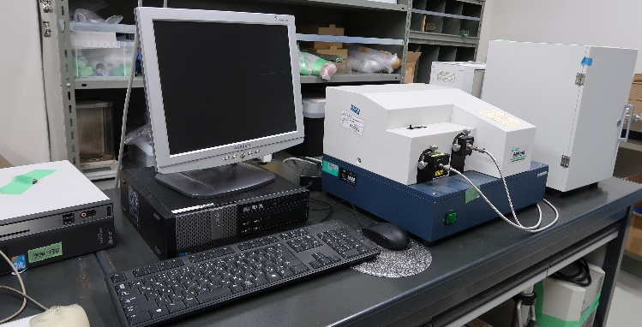

Fig. 1. Overview of Raman microspectro photometer system; Computer controlled spectro photometer was separated from micrometer which is enclosed in a box and conneceted with optical fiber.

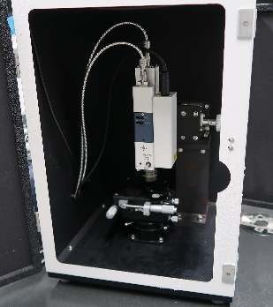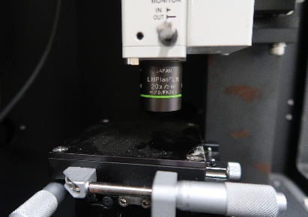

Fig. 2. Microscope inside the optically sealed box and close up of stage part.

Fig

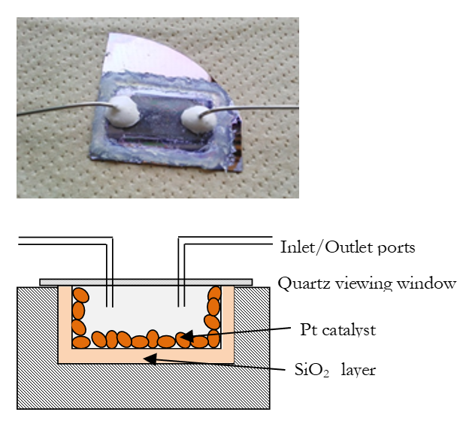
Fig. 3. Overview of in situ microchannel catalytic cell and Schematic diagram of the cross-sectional view.

Fig.

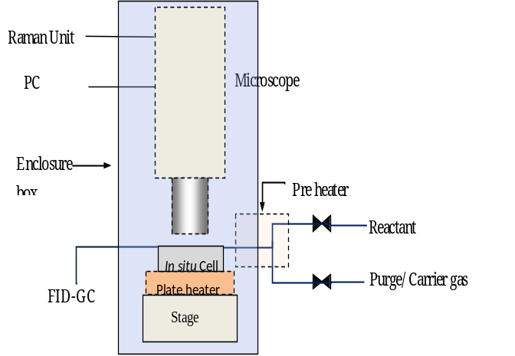

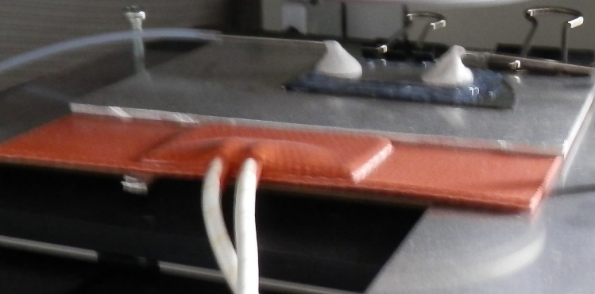

Fig. 4. Schematic diagram of the experimental set-up during the in situ microspectroscopic observation and close up photograph of heating unit on the micrometer stage.

  - Experimental Sequence

Two experimental sequences were used to gather the Raman spectra during the reaction, as presented in Fig. 5. The first sequence shown in Fig. 5(a) was devised to perform a blank test using the cell without the catalyst. The cell was first purged with N₂ fed at the rate of 60ml/h for 30 min at 393 K. Towards the end of N₂ purging, the background (BG) was collected. After this, the model reactant was pumped into the cell through preheater at 393 K, while the N₂ line was kept open. After spectroscopic measurements were made, the cell was then consecutively purged with N₂ (60 ml/h, 30 min) and H₂ (60 ml/h, 30 min) to remove the gaseous reactant and adsorbed species respectively.
The second experimental sequence shown in Fig. 5(b) was used to observe the reaction in the cell containing the silica supported Pt catalyst. Pretreatment was carried out with H₂ fed at the rate of 60 ml/h for 30 min at 423 K to reduce the platinum catalyst and remove the impurities from the catalyst surface. The temperature was then lowered and maintained at 393 K, after which, N₂ was fed at the rate of 60 ml/h for 30 min at 393 K. The succeeding steps including the background and spectrum measurement during the reaction, as well as N₂ and H₂ purging conditions employed were same as the first experimental sequence. During the reaction products were sampled at the outlet and analysed by FID-GC.

(a)
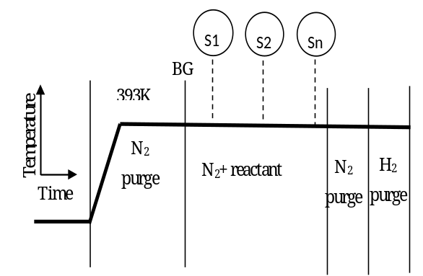

(b)
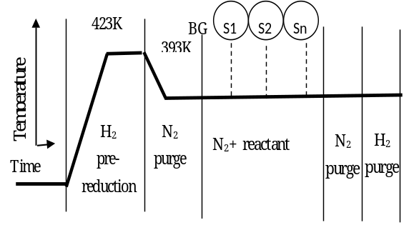

Fig. 5. Experimental sequence for in situ Raman microspectroscopic measurement (a) without Pt catalyst and (b) with Pt catalyst.

- Results and Discussions

  - Blank Test

Raman spectra of pure materials were observed at 393 K using in situ cell with SiO₂/Si support wall without Pt catalyst. Fig. 6 show respective spectra of cyclohexane, cyclohexene and benzene, which were obtained subtracting N₂ flow-spectrum from spectrum taken with mixed flow of respective reagent in N₂ carrier gas. No reaction products were observed by FID-GC during the observation period.
As shown in Fig. 6-1, cyclohexane shows peaks at 2,900 cm⁻¹ and 2,800 cm⁻¹ indicating C-H of CH₂ group as well as C-C group at 800 cm⁻¹. Cyclohexene (Fig. 6-2) shows an additional peak at 3,000 cm⁻¹ indicating C-H of C=C group. Benzene (Fig. 6-3) only shows a peak of aromatic C-H at 3,100 cm⁻¹. No indication on the reaction of these materials were observed showing that the SiO₂ reactor wall was inactive under these conditions.

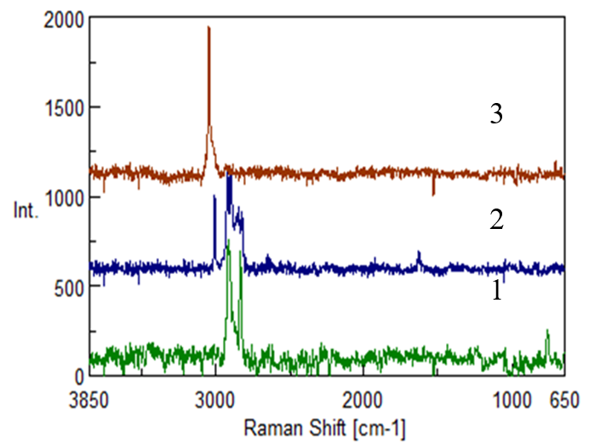
Fig. 6. Blank test without Pt catalyst component.
1: cyclohexane, 2: cyclohexene and 3: Benzene was flown into the cell at 393 K.
  - Reaction Test

Dehydrogenation reaction of cyclohexane was carried out at 393 K for about 3 h over the Pt catalyst supported on SiO₂/Si tube wall inside the in situ cell. Both cyclohexene and benzene was observed as products by GC analysis.
Figure 7 shows the change in conversion with reaction time. Initial conversion was about 2% and decreased gradually. Figure 8 shows the Raman spectra of catalytic

wall at the middle of the reactor during and after reaction. Spectra at the reaction time 0-1 h, 1-2 h and 2-3 h are represented by Figs. 8-1, -2 and -3, respectively.
These spectra shows typical spectra of cyclohexane at saturated C-H region of 2,900 cm⁻¹ and 2,800 cm⁻¹ in addition to 800 cm⁻¹ representing C-C bonding. No such peaks representing unsaturated C-H bands (3,000-3,100 cm⁻¹) were observed. This is because low concentration of produced cyclohxene and benzene. Additional peaks were observed at 1,600 cm⁻¹, 1,450 cm⁻¹ and 1,350 cm⁻¹. Peaks at 1,600 cm⁻¹ and 1,350 cm⁻¹ are typical spectra of carbon like material so called G-band and D-band, respectively. These bands indicate formation of carbonaceous materials both graphitic structure (G-band) and amorphous structure (D-band) during the reaction. As shown in Fig. 8-3, the increase of G-band intensity with time suggests that the polymerization of aromatic structure accumulates graphitic carbon on the surface. It is well known that the accumulation of carbon materials on the catalyst surface causes deactivation of catalysts [21].
It is suggested, therefore, the deactivation shown in Fig. 7 might be caused by surface carbonaceous deposits accumulated by polymerization of aromatic precursors. This coincides the in situ UV-Vis observation results on dehydrogenation of 1-methyl-1, 4-cyclohexadiene which suggested coke formation with polyolefinic constituents [20].
In the previous study on the in situ micro-infrared observation of the same reaction system, π-allylic species has been observed during the reaction [19]. This results supports the identification of new Raman peak of 1,450 cm⁻¹ as π-allylic reaction intermediates.

Fig. 7. Change in conversion with time at 393 K. Dehydrogenation of cyclohexane was carried out on the Pt/SiO2 catalyst in in situ microcatalytic reactor cell for Raman observation

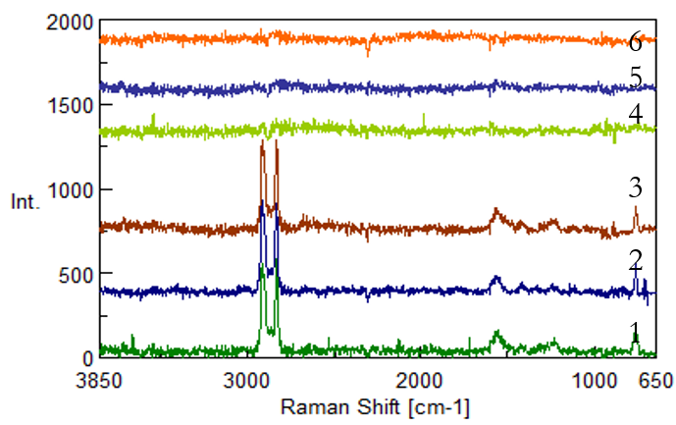
Fig. 8. In situ Raman spectra during the dehydrogenation reaction of cyclohexane at 393K over Pt/SiO₂ catalyst in microcatalytic reactor cell.
1: During reaction (0-60min), 2: During reaction (60-120min), 3: During reaction (120-180),
4: N₂ purge (0-15min), 5: N₂ purge (30-75min), 6: H₂ treatment (30-75min)

  - Post Reaction Treatment

After the reaction test, the cell was post treated at 393 K. Figure 8-4 shows the results just after N₂ purge. Additional N₂ treatment for 75min and following H₂ treatment for 75min are shown in Fig. 8-5 and -6, respectively. All the peaks were disappeared just after N₂ purge, so that gaseous cyclohexane as well as π-allylic intermediates are easily removed both gas phase and catalyst surface. Because peaks of carbon like materials were also disappeared, the interaction of carbon and surface might be not so strong.

- Conclusions

A Raman microspectrophotometer was used to perform in situ characterization of the activity of the silica supported platinum catalyst in the microchannel catalytic reactor. A catalytic microreactor cell was designed and used for the dehydrogenation of cyclohexane as a model reaction. The spectra were collected under the reaction conditions.
Without platinum catalyst component, no reaction of either reactant or product unsaturated compounds were observed at 393 K. When Pt catalyst was supported on the SiO₂ reactor wall, GC analysis showed that dehydrogenation reaction has started at 393 K and Raman shift of 1,450 cm⁻¹ which was identified as π-allylic intermediates were observed. At the same time, Peaks at 1,600 and 1,350 cm⁻¹ were observed. These could be identified as graphitic carbon and amorphous carbon, respectively. These carbon materials on the surface might cause the deactivation of the catalyst. All the Raman spectra were easily removed by N₂ gas purging at 393 K.

Acknowledgement

The authors would like to acknowledge funding support by KAKENHI 15H04178.

References

- B. M. Weckhuysen, Ed., “Recent advances in the in situ characterization of heterogeneous catalysts,” Chemical Society Reviews, vol. 39, pp. 4541-5072, 2010.
- T. Tagawa and Y. Amenomiya, “An infrared spectroscopy system for catalytic reaction at elevated pressure and temperature,” Applied Spectroscopy, vol. 39, pp. 358-259, 1985.
- T. Tagawa, G. Pleizier, and Y. Amenomiya, “Methanol synthesis from O₂+H₂ 1. Characterization of catalysts by TPD,” Applied Catalysis, vol. 18, pp. 285-293, 1985.
- T. Tagawa, N. Nomura, M. Shimakage, and S. Goto, “Effect of supports on copper catalysts for methanol synthesis from CO₂+H₂,” Res. Chem., Intermed., vol. 21, pp. 193-202, 1995.
- N. Nomura, T. Tagawa, and S. Goto, “In situ FTIR study on hydrogenation of carbon dioxide over titania supported copper catalysts,” Applied Catalysis A: General, vol. 166, pp. 321-326, 1998.
- N. Nomura, T. Tagawa, and S. Goto, “Promotion effect of Fe on hydrogenation of carbon dioxide over CuO-ZnO/TiO₂ catalyst,” J. Chem. Eng. Japan, vol. 31, pp. 41-46, 1998.
- I. E. Wachs and F. D. Hardcastle, “Applications of Raman spectroscopy to heterogeneous catalysis,” Catalysis, vol. 10, pp. 102-53, 1993.
- G. Mestl, “In situ Raman spectroscopy — a valuable tool to understand operating catalysts,” J Mol Catal A: Chem, vol. 158, pp. 45-65, 2000.
- I. E. Wachs, “In situ Raman spectroscopy studies of catalysts,” Topics of Catalysis, vol. 8, pp. 57-63, 1999.
- P. C. Stair, “Advances in Raman spectroscopy methods for catalysis research,” Current Opinion in Solid State Materials Science, vol. 5, pp. 365-369, 2001.
- R. A. Schoonhedyt, “UV-VIS-NIR Spectroscopy and microspectroscopy of heterogeneous Catalysts,” Chem. Soc. Rev., vol. 39, pp. 5051-5066, 2010.
- M. D. Argyl, K. Chen, E. Iglesia, and A. T. Bell, “In-situ UV-Visible spectroscopic measurements of kinetic parameters and active site for catalytic oxidation of alkanes and vanadium oxides,” J. Phys. Chem. B, vol. 109, pp. 2414-2420, 2005.
- W. Ehrfeld, et al., Microreactors. Weinheim: Wiley-VCH, 2000.
- K. Haas-Santo, “Preparation of microstructure compatible porous supports by Sol-gel synthesis for catalyst coatings,” Applied Catal. A: General, vol. 220, pp. 79-92, 2001.
- K. K. Moe, T. Tagawa, and S. Goto, “Preparation of electrode catalyst for SOFC reactor by ultrasonic mist pyrolysis of aqueous solution,” J. Ceram. Soc. Japan, vol. 106, 242-247, 1998.
- A. S. Carrillo, T. Tagawa, and S. Goto, “Application of mist pyrolysis method to preparation of Ni/ZrO₂ anode catalyst for SOFC type reactor,” Mater. Res. Bul., vol. 36, pp. 1017-1027, 2001.
- T. Tagawa, Shimizu, and S. Goto,” Effect of silica layer on the catalytic activity of platinum on the silicon chip for the microchannel reactor,” Materials Forum, vol. 29, pp. 205-209, 2005.
- T. Tagawa, A. Kanemoto, H. Itoh, and H. Yamada, “Effect of support materials upon platinum catalyst prepared on the wall surface of silicon microchannel,” Catal. Today, vol. 147, pp. S36-S40, 2009.
- T. Tagawa, M. Isobe, M. Tanaka, and H. Yamada. “Evaluation of catalyst prepared in microchannel with in situ FT-IR microscopy,” Chem. Eng. J., vol. 167, pp. 427-430, 2011.
- E. G. T. Suarnaba, Y. F. Lee, H. Yamada, and T. Tagawa, “Ultraviolet-Visible (UV-Vis) micro-spectroscopic system designed for the In Situ characterization over platinum supported catalytic microchannel reactor,” Applied Spectroscopy, vol. 70, no. 11, pp. 1806-1812, 2016, doi: 10.1177/0003702816671071, 2016.
- L. Liwu, Z. Tao, Z. Jingling, and X. Zhusheng, “Dynamic process of carbon deposition on Pt and Pt-Sn catalysts for alkane dehydrogenation,” Applied Catalysis, vol. 67, pp. 11-23, 1990.

Tomohiko Tagawa, photograph and biography not available at the time of publication.

Takuya. Kikkawa, photograph and biography not available at the time of publication.

Hiroshi Yamada, photograph and biography not available at the time of publication.

Emee Grace Tabares Suarnaba, photograph and biography not available at the time of publication.

